Student worksheet answers

1.1 Scientists review the research of other scientists

Pages 2–3

Scientific research

1 Which scientist is called the ‘father of genetics’?

Gregor Mendel

2 What is the term used today to describe Mendel’s ‘factors’?

Genes

3 Name the two important principles Mendel identified that form the basis of genetics today.

Independent assortment and segregation

4 If you inherit your curly hair from your father, does this mean you will also inherit your father’s blue eyes? Give a reason for your answer.

No, just because you inherit curly hair from your father does not mean you will also inherit his blue eyes. This is because each factor is inherited independently of any other factor.

5 Explain how Mendel proved that factors are NOT blended together, as was previously thought.

Mendel worked with pea plants to show that factors are not a mixture of each parent but are inherited independently. Each characteristic comes as a pair of factors that are first separated from each other and then one is inherited from each parent. This occurs independently for each factor/gene, giving rise to pea parents with a combination of characteristics – some similar and some different to the parent plants.

6 Watson and Crick described the structure of DNA as a double helix. What does this mean?

A coiled structure made up of two strands that twist around each other in opposite directions.

7 Match the scientists with the correct contribution they gave to genetics.

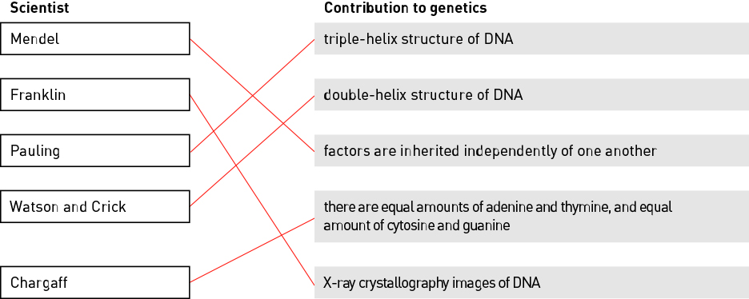

Extend your understanding

8 Explain why it is important for scientists to collaborate and share their research.

Answers will vary. Example answer:

The sharing of knowledge and research between scientists leads to scientific breakthroughs. Improvements in our understanding of science may lead to cures for disease, development of drugs, improved crops, and sustainability.

Student worksheet answers

1.2 DNA consists of a sugar-phosphate backbone and four complementary nitrogen bases

Pages 4–5

The composition of DNA

1 Name the chemical that all genes are made up of.

DNA (deoxyribonucleic acid)

2 Name the four complementary nitrogen bases.

Adenine, guanine, cytosine, thymine

3 Identify the type of cell that contains no DNA.

Mature red blood cells

4 Label the three components of the nucleotide shown below.

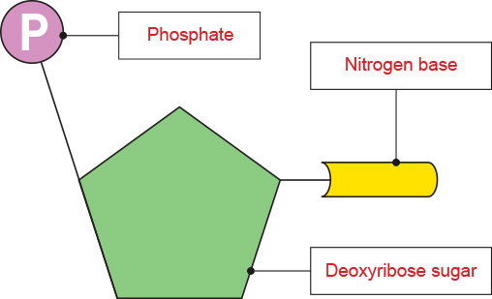

5 Fill in the blanks.

The bases adenine and thymine are joined by two hydrogen bonds, while cytosine and guanine are joined by three hydrogen bonds.

6 Describe the two vital roles of a DNA molecule.

DNA carries information – the sequence of bases within DNA codes for proteins.

DNA makes copies of itself (self-replication).

7 A strand of DNA has the base sequence AATGCGATGC. Give the base sequence for the complementary strand.

TTACGCTACG

Extend your understanding

Nitrogen bases always exist as complementary base pairs within a DNA molecule. Adenine is always paired with thymine, while cytosine is always paired with guanine.

8 Consider a particular gene with a total of 100 bases. If 24 of these bases are adenine, how many thymine, cytosine and guanine bases would there be?

There must be 24 thymine bases (to pair with the 24 adenine bases). This accounts for 48 of the bases, so the other 52 bases must be cytosine–guanine pairs. Therefore, there are 26 cytosine bases and 26 guanine bases.

9 By studying the structure of DNA, more knowledge is gained to assist us in other areas of science; for example, in the treatment of medical disorders such as diabetes. Suggest three other areas of science that may benefit from studying the structure of DNA.

Answers will vary and may include ideas such as:

Curing diseases, drug development, food quality and yield, improved sustainable farming practices, biotechnology, identifying similarities and differences between individuals of the same species and different species.

Student worksheet answers

1.3 Chromosomes are DNA molecules carrying genetic information in the form of genes

Pages 6–9

Chromosomes

1 Order the following terms from smallest to largest.

Gene Chromosome Nucleotide Phosphate

Phosphate, Nucleotide, Gene, Chromosome

2 Circle the sex chromosomes shown in in the human karyotype below.

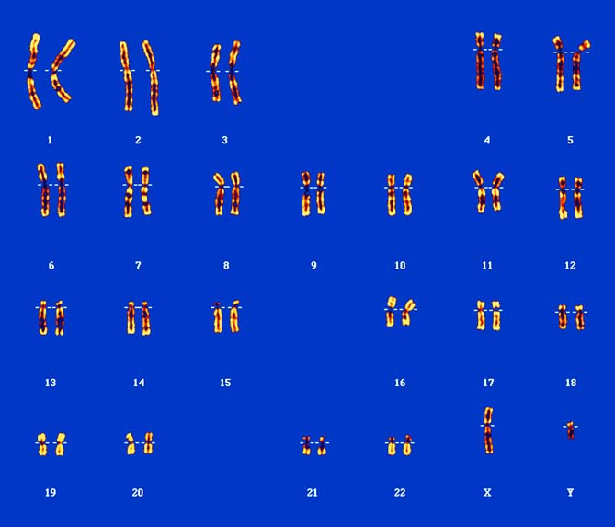

3 Is the karyotype above for a male or a female? How can you tell?

For a male, as it shows one X chromosome and one Y chromosome. If it were for a female, there would be two X chromosomes.

4 If unravelled, the DNA of a single cell would be approximately 2 metres long. Explain how it fits inside a cell.

DNA is tightly coiled around histone proteins, which are also coiled together, condensing the DNA into chromosomes that fit within a single cell.

5 A gene is a section of DNA. Explain what makes one gene different from any other gene within a DNA strand.

The nitrogen base sequence within the particular section of DNA for a gene makes it different from any other gene.

6 Fill in the blanks.

Proteins are made up of smaller subunits calledamino acids that are joined together bypeptide bonds during the process of translation.

7 Name the two processes shown in the diagram below.

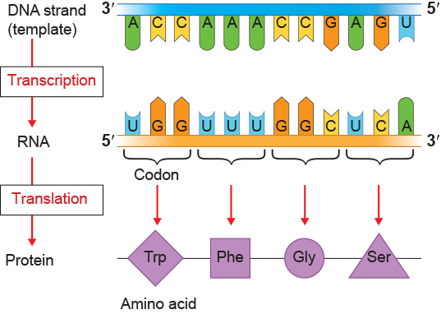

8 Complete the Venn diagram to compare the similarities and differences between DNA and RNA. Do this by placing each key word from the list in the correct position on the diagram. The first key word has been completed for you.

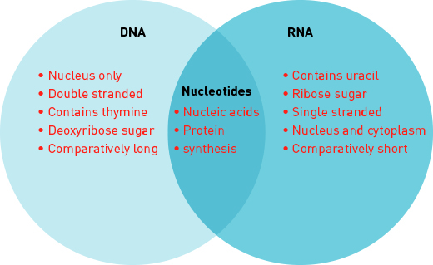

9 Transcribe the following DNA template sequence into an RNA sequence.

DNA template: GAT ACC GCA TTC

RNA sequence: __________________

RNA sequence: CUA UGG CGU AAG

Extend your understanding

Our bodies are made up of proteins, which consist of different combinations of 20 amino acids that are joined together during translation.

9 Use the internet to research the sources of these 20 amino acids that are used within our cells during protein synthesis.

While some amino acids can be synthesised by our bodies, the rest (called essential amino acids) are obtained from the protein within our diet. These proteins are broken down into amino acids during digestion, and are then absorbed into the small intestine and into our bloodstream. The amino acids circulate within our blood stream and are transported into our cells to be used during protein synthesis.

Student worksheet answers

1.4 Mitosis forms new somatic cells

Pages 10–11

Mitosis

1 Match each term with the correct definition.

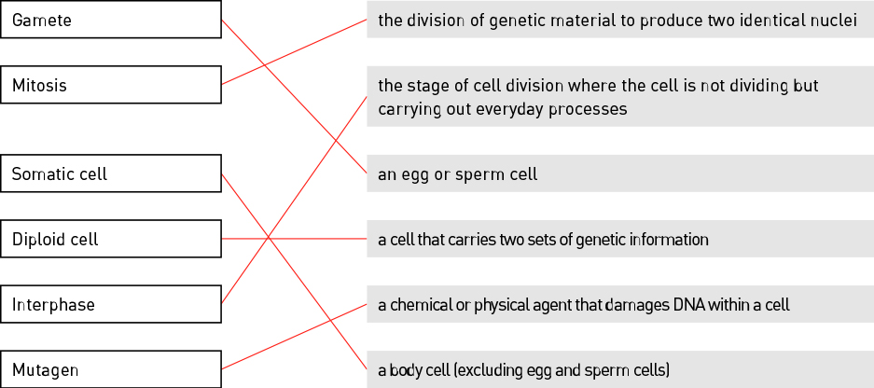

2 Identify the stage of mitosis shown in the following image.

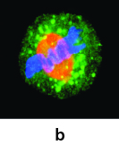

Metaphase

3 Describe what occurs during this stage of mitosis.

The chromosomes line up along the centre of the cell in a single line.

4 Why do somatic cells need to undergo mitosis?

For an organism to grow and to repair damage

5 Identify three ways a cell’s DNA can become damaged:

Radiation, viruses and mutagens

6 Explain why a cell undergoes apoptosis.

Apoptosis is programmed cell death. This occurs because it is a programmed part of a cell’s DNA as a cell cannot continue to survive and carry out mitosis indefinitely. Apoptosis is also carried out if an error occurs within a cell.

7 Fill in the blanks.

The processes of mitosis and cytokinesistogether produce two new, genetically identical daughter cells.

8 Explain why a cancerous cell continues to carry out mitosis rather than being destroyed by apoptosis.

Cancerous cells have damaged DNA that has not been identified by the cell, and so the cancerous cell continues to carry out mitosis even though apoptosis should have occurred.

9 Label the stages of mitosis shown in the image below.

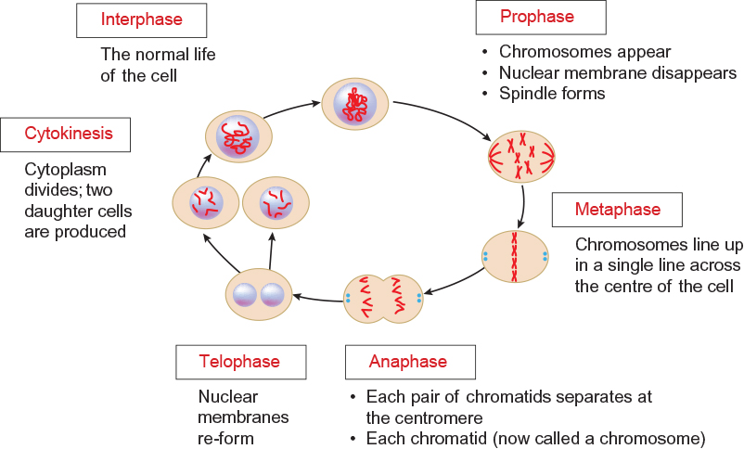

Extend your understanding

10 Identify the cell types that undergo mitosis by writing ‘yes’ or ‘no’ in the table.

|  |  |
| --- | --- |
| Cell type | Mitosis? (yes or no) |
| Bone cell | Yes |
| Egg cell | No |
| Intestinal cell | Yes |
| Nerve cell | Yes |
| Sperm cell | No |

11 Explain why only some of the cells listed in the table above undergo mitosis.

Only somatic cells carry out mitosis, which is required for growth, repair and replacement. Egg and sperm cells are gametes and are involved in reproduction, so these cells do not undergo mitosis.

Student worksheet answers

1.5 Meiosis forms gamete cells

Pages 12–13

Meiosis

1 What is a gamete cell?

Sex cells produced during meiosis

2 Fill in the blanks.

The process of meiosis produces gametes, which fuse during the process of fertilisation to produce a zygote, the first diploid cell of a new organism.

3 How many stages are in the process of meiosis and what are they called?

Two stages: meiosis I and meiosis II

4 What happens to the number of chromosomes in meiosis?

The number of chromosomes is halved

5 Complete the table below by determining which type of cell division (mitosis or meiosis) occurs in each cell type.

|  |  |
| --- | --- |
| Cell type | Type of cell division |
| Bone cell | Mitosis |
| Ovum | Meiosis |
| Guard cell | Mitosis |
| Skin cell | Mitosis |
| Sperm cell | Meiosis |

5 If a goldfish’s intestinal cells each contain 94 chromosomes, how many would be present in the goldfish eggs produced by a female goldfish? Explain your answer.

Each egg cell will contain 47 chromosomes. Egg cells are gamete cells with a haploid set of chromosomes. They will therefore halve half the number of chromosomes of a somatic, diploid intestinal cell.

6 What does the ‘*n*’ and ‘2*n*’ represent in the diagram shown?

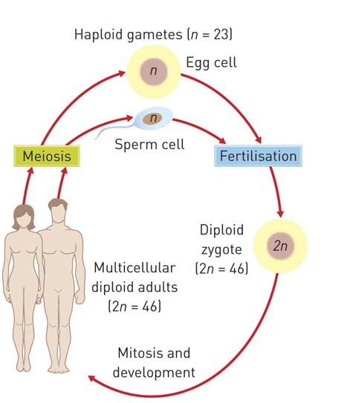

The *n* represents a haploid set of chromosomes found in gamete cells such as the egg and sperm cell shown. The 2*n* represents a full diploid set of chromosomes found in somatic cells such as the zygote shown.

7 Outline how four gamete cells form from a single diploid cell during the process of meiosis I and meiosis II.

Meiosis has two divisions. The first division, meiosis I, involves the DNA being replicated and the original diploid cell dividing to form two diploid cells. The second division, meiosis II, divides these two cells again to produce four haploid gametes with half the number of chromosomes as the parent cell.

Extend your understanding

8 Suggest why meiosis is also referred to as reduction division.

Meiosis halves the number of chromosomes in two divisions: meiosis I and II. Although DNA replication occurs, and initially two diploid cells are created, a second division reduces the diploid (2*n*) set of chromosomes to a haploid (*n*) set of chromosomes within each gamete.

Student worksheet answers

1.6 Alleles can produce dominant or recessive traits

Pages 14–15

Alleles

1 What is an allele?

The different versions of a gene

2 Describe the difference between the terms genotype and phenotype.

Genotype is the allelic symbols given to a gene. Phenotype is the physical expression of a trait resulting from the genotype and environmental influence.

3 The diagram below is of a pair of chromosomes and shows the alleles for hair colour.

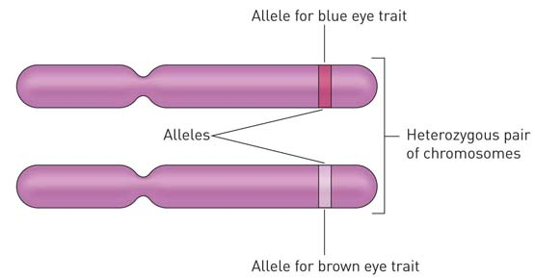

For eye colour (B) of this individual, determine

a genotype: Bb

b phenotype: Brown eyes

4 Write definitions for the following terms.

|  |  |
| --- | --- |
| Term | Definition |
| Gene | A section of DNA that codes for a characteristic. |
| Loci | The position of a gene along a chromosome. |
| Chromosome | A molecule of DNA containing genes that is coiled around histone proteins. |
| Carrier | A heterozygous individual that has a dominant phenotype but carries a recessive allele. |

5 Attached earlobes (E) is dominant to unattached earlobes. Write down the possible genotypes of

a attached earlobes: Ee or EE

b unattached earlobes: ee

c carriers: Ee

6 Long eyelashes (L) is dominant to short eyelashes. A woman and man, both with long eyelashes, have two children. The daughter has long eyelashes and the son has short eyelashes. Write the possible genotypes for each parent and child.

a Mother: Ll

b Father: Ll

c Daughter: LL or Ll

d Son: ll

7 Right-handedness (H) is dominant to left-handedness. A right-handed man and a right-handed woman have two children that are both left-handed. Complete the Punnett square below and indicate how two right-handed parents can have two left-handed children.

|  |  |  |  |  |
| --- | --- | --- | --- | --- |
|  |  | Father | |  |
|  |  | H | h |  |
| Mother | H | HH | Hh |  |
| h | Hh | hh | There is a 25% chance of each child being left-handed. |

Extend your understanding

8 Short hair is dominant over long hair in guinea pigs. A student has a female guinea pig with short hair. The student wants to purchase a male guinea pig and breed the guinea pigs safely and ethically to produce only short-haired babies.

a What phenotype male guinea pig would the student need to buy?

A short-haired male

b Explain why the student could not guarantee that all the babies will also have short hair.

The student would not know whether each parent is a carrier for long hair or not until he or she breeds them. The student only needs one parent to be homozygous dominant and they will never produce any long-haired guinea pigs. However, if both are carriers and heterozygous for short hair, there is a 25% chance of each baby being long-haired and eventually the student will produce some long-haired babies.

Student worksheet answers

1.7 Alleles for blood group traits co-dominate

Pages 16–17

Co-dominant traits

1 What is co-dominance?

Neither allele is dominant over the other so both are expressed when present.

2 List all the different alleles for ABO blood grouping.

IA, IB, i

3 Which allele is recessive and which alleles are co-dominant with regards to ABO blood grouping?

i is recessive; IA and IB are co-dominant

4 What is the phenotype for each of the following individual’s genotypes?

a IA IB

AB

b IBi

B

c ii

O

d IBIB

B

5 What percentage of individuals are rhesus negative?

20% (80% of people have the rhesus markers present on the surface of their red blood cells).

6 Emma has the genotype IAIB and Geoff has the genotype IAi.

a What is Emma’s phenotype? AB

b What is Geoff’s phenotype? A

c Draw a diagram in the space below to show how the surface of Emma’s red blood cells differ to those of Geoff’s.

Emma’s red blood cells:

*Diagrams will vary. Example:*

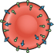

Geoff’s red blood cells:

*Diagrams will vary. Example:*

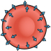

d Complete the Punnett square below to determine the possible genotypic and phenotypic ratios of Emma and Geoff’s children.

|  |  |  |  |
| --- | --- | --- | --- |
|  |  | Geoff | |
|  |  | IA | i |
| Emma | IA | IAIA | IAi |
| IB | IAIB | IBi |

Genotypic ratio: ¼ IAIA : ¼ IAi : ¼ IAIB : ¼ IBi

Phenotypic ratio: ½ A : ¼ AB : ¼ B

Extend your understanding

7 Explain why it is preferable for a patient to be given the same blood group when receiving a blood transfusion.

Red blood cells contain different proteins on their surface. While one individuals red blood cells have A proteins on the surface, another individual may have B proteins. A person with only A proteins can only receive A (or O) blood. These blood groupings are carefully checked prior to a transfusion. If a patient receives blood proteins not present in their blood, clots may form, which can block blood vessels and result in death.

8 Explain why it is possible in an emergency for a patient who is AB+ to receive blood from any other blood group, while a patient who is O– can only receive blood from an O– donor. You may need to use the internet to research this topic.

A patient with AB+ blood group has both A proteins and B proteins on the surface of their red blood cells. They can therefore receive blood from any blood group (as O types contain no proteins on the surface of the red blood cells). They can also receive rhesus positive or negative blood. A patient who is O– does not have A or B proteins on the surface of their cells, so can therefore only receive blood from another O blood group. Because rhesus negative individuals will destroy rhesus positive red blood cells, they can only receive blood from O– individuals.

Student worksheet answers

1.8 Alleles on the sex chromosomes produce sex-linked traits

Pages 18–21

Sex-linked traits

1 What are autosomes?

Non-sex chromosomes. In humans, chromosomes 1–22 are autosomes.

2 What are sex chromosomes?

The chromosomes that determine the sex of an organism.

3 What sex chromosomes does a human male have?

X and Y

4 Does a human male’s Y chromosomes come from his mother or his father? Why?

His father. A female has 2 X chromosomes. Therefore, she can only give her offspring an X chromosome. A male can give either an X (to his daughter), or a Y (to his son).

5 Fill in the blanks.

In humans, the genotype of a female is XX and the genotype of a male is XY.

6 Identify which is the X chromosome and which is the Y chromosome in the image below:

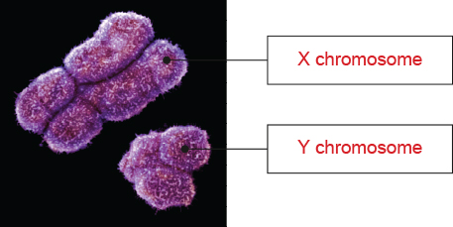

7 Name the term used to describe traits and genes that are carried on the sex chromosomes.

Sex-linked

8 Give ONE example of a non-sexual trait that is carried on the human X chromosome.

*Answers may vary.* Examples include red–green colour vision and blood clotting.

9 Explain why there is a greater percentage of males than females that have red–green colour blindness.

Red–green colour blindness is an X-linked recessive trait. This means the gene is located on the X chromosome. Because males only have one X chromosome, it means if this allele is present they will have the trait. They cannot be carriers.

10 Match the patterns of inheritance with the correct example.

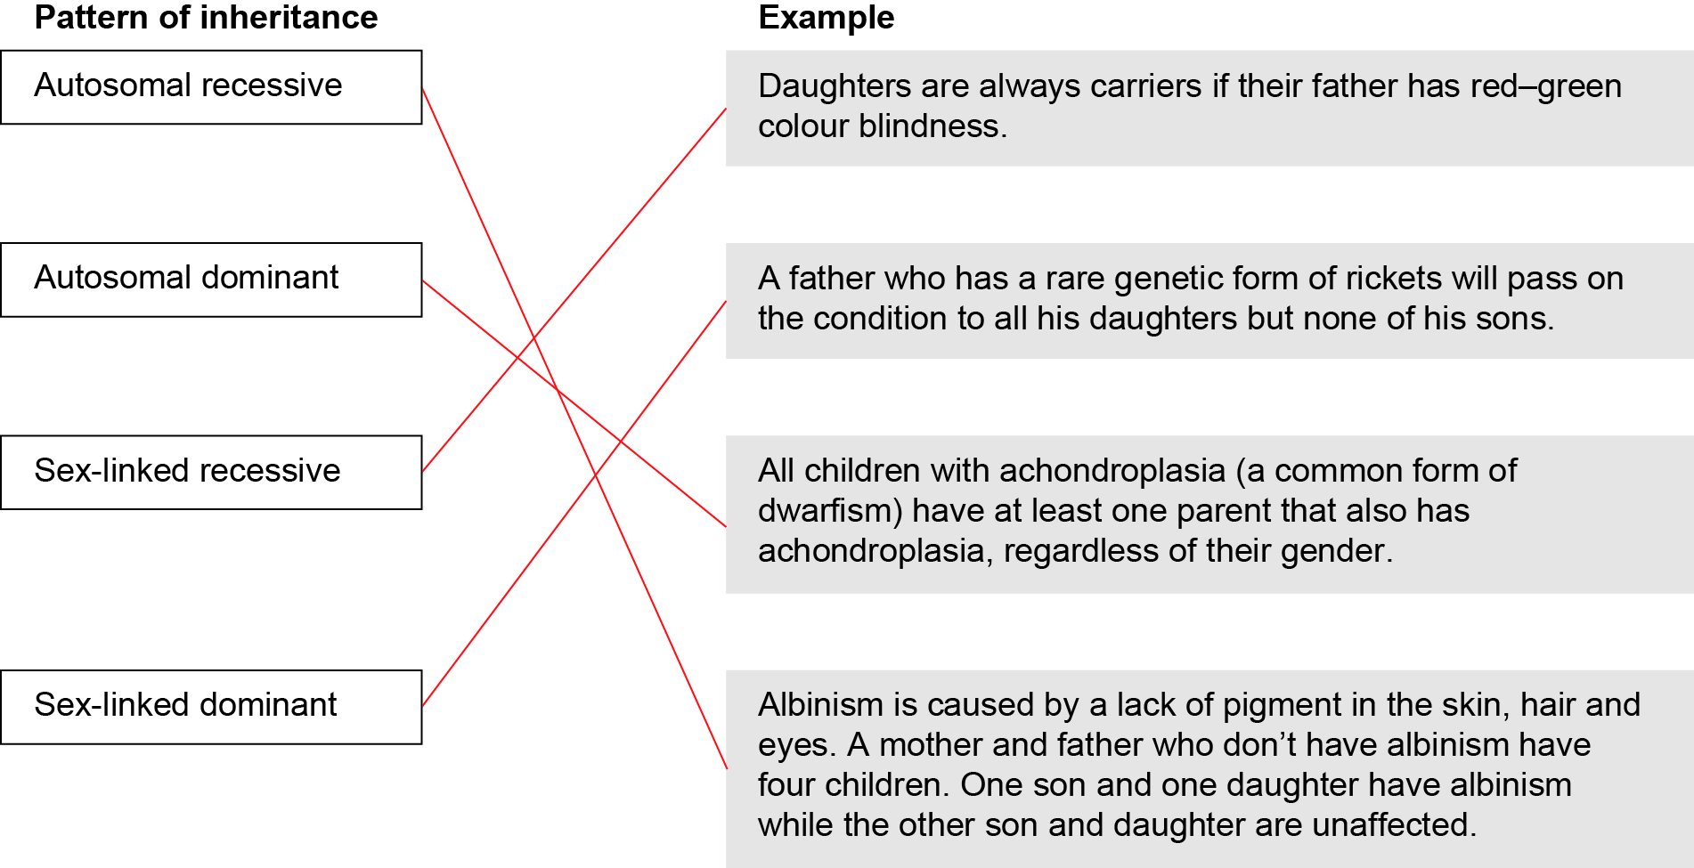

11 Suggest how a man and woman, both with normal sight, could have children that have red–green colour blindness. Include a Punnett square in your answer.

The woman must be a carrier with the genotype XcX. The male has normal sight so must have the genotype XY. This means they could have daughters with normal sight (XcX and XX) and sons both normal (XY) and affected (XcY).

Extend your understanding

12 Suggest why sex-linked traits are more frequently found on the X chromosome than on the Y chromosome, and explain how this affects the inheritance of these traits differently in males and females.

The X chromosome is much larger than the Y chromosomes and contains many more genes, therefore more sex-linked traits are found on the X chromosome. Females can be heterozygous for any traits found on the X chromosome while males only have one allele for these genes located on their single X chromosome.

Student worksheet answers

1.9 Inheritance of traits can be shown on pedigrees

Pages 22–25

Pedigrees

1 What does a pedigree show?

A pedigree is a diagrammatic way to show how a trait is inherited over two or more generations.

2 Match the following pedigree symbols with the correct meaning.

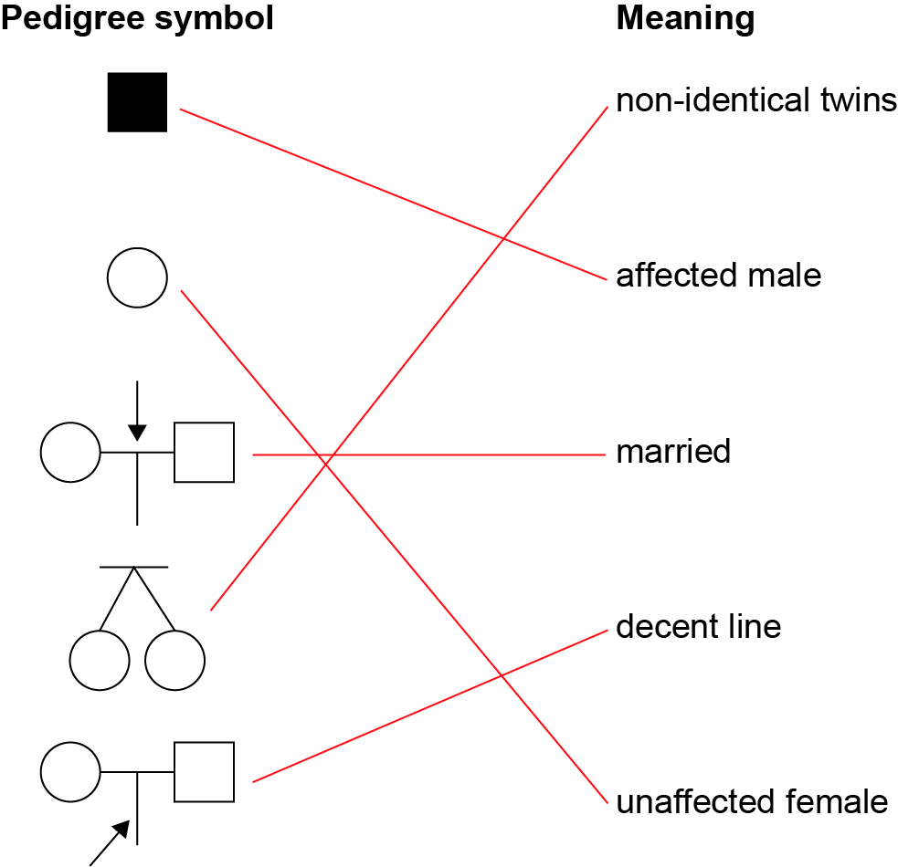

3 What is the symbol in a pedigree for an affected female?

A shaded circle

4 What are used to represent different generations in a pedigree?

Roman numerals

5 If affected children always have affected parents, what is the pattern of inheritance of the characteristic?

Sex-linked dominant

6 The pedigree below shows the inheritance of haemophilia, a sex-linked recessive disease that prevents blood from clotting.

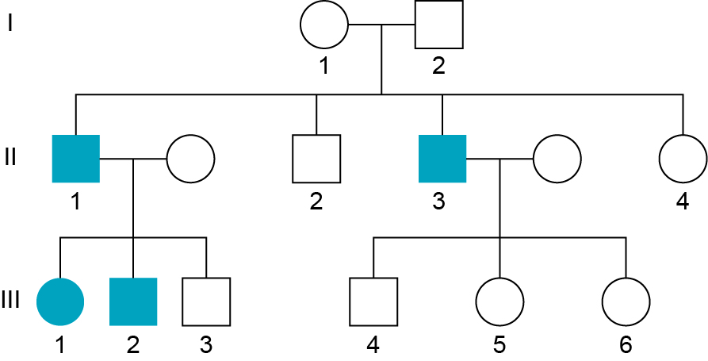

a Use appropriate symbols to write the genotype of individuals I1 and I2 from the pedigree.

Individual I1: XRXr

Individual I2: XRY

b Explain how you determined their genotypes.

The male is unaffected so must have XR (if he was Xr he would be affected and have haemophilia). The female does not have haemophilia so must have one XR; however, she has sons that do have haemophilia and therefore she must have one Xr.

7 Analyse the pedigree below to answer the questions that follow.

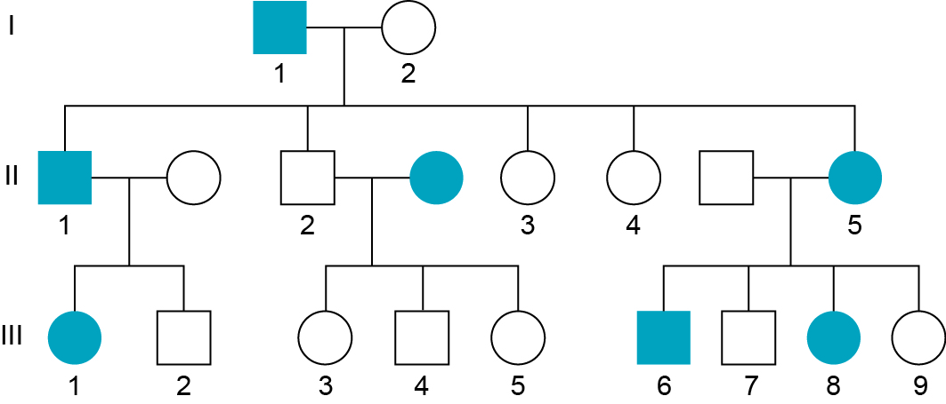

a List the numbers of all the affected males.

I1, II1 and III6

b How many children were born in the second generation?

5

c Determine the pattern of inheritance by analysing the pedigree. Justify your choice.

This is an autosomal, dominant pattern of inheritance.

Students answers will vary depending on individuals analysed; for example:

If it was a sex-linked trait, females II3 and II4 would be affected as they would receive an affected X chromosome from their affected father (I1). Therefore, it is autosomal. It must be a dominant trait, as every affected child has an affected parent and there is a 50% chance of an affected allele beingpassed on from one parent.

Extend your understanding

Cystic fibrosis is an inherited disease of the secretory glands, primarily affecting the lungs. It is an autosomal, recessive disease. A couple, both unaffected by cystic fibrosis have three children. The third child has cystic fibrosis.

8 Using appropriate symbols, complete a Punnett square and basic pedigree in the space below to show how two unaffected parents could have one of their three children with cystic fibrosis. Add as much detail as possible to your pedigree.

*Student answers may vary. Example Punnett square:*

|  |  |  |  |
| --- | --- | --- | --- |
|  |  | Parent 1 | |
|  |  | D | d |
| Parent 2 | D | DD | Dd |
| d | Dd | dd |

9 What is the chance of the two unaffected children being carriers?

50%

10 The couple would like to have another child. What are the chances this child will also have cystic fibrosis?

25%

11 The couple would probably benefit from genetic counselling before making the decision to have another child. Using the internet, find out what genetic counselling provides to families with inherited disorders.

Genetic counselling provides a family with knowledge about an inherited disorder and the chances of it being passed on, as well as the chances of their unaffected children passing it on to their own children in the future.

Student worksheet answers

1.10 Mutations are changes in the DNA sequence

Pages 26–29

Mutations

1 Complete the following table by identifying the correct terms and writing definitions in the spaces provided.

|  |  |
| --- | --- |
| Term | Definition |
| Genetic mutation | A permanent change in the nucleotide sequence of a single gene. |
| Mutagen | Environmental factor that increases the frequency of a mutation. |
| Chromosomal mutation | A permanent change in the nucleotide sequence of DNA that affects most of a chromosome. |
| Radiation | Forms free radicles that cause damage to DNA and proteins. |
| Triplet | A group of three bases on DNA. |
| Non-disjunction | Failure of a chromosome pair to separate during meiosis. |

2 Use the image below to answer the following questions.

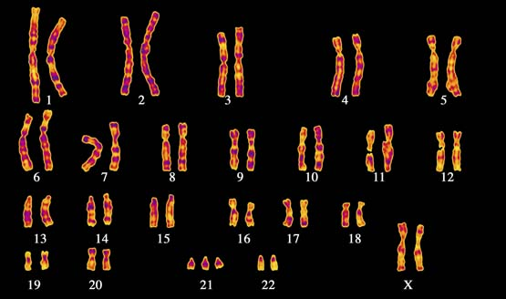

a Which chromosome has had a change in number?

Chromosome 21

b What syndrome does this person have?

Down syndrome

c Is this a chromosomal mutation or a genetic mutation?

Chromosomal mutation

d Outline how this type of mutation occurs during meiosis.

This chromosomal mutation occurs due to non-disjunction in chromosome pair 21 during the formation of gametes in meiosis. Once this abnormal gamete (with two copies of chromosome 21 rather than one) is fertilised, the offspring will have trisomy 21 and have Down syndrome.

3 Use the following nucleotide sequence to answer the questions.

AGG GAT CCG ATA ACC

a Rewrite the nucleotide sequence to demonstrate a mutation where the first thymine is substituted for guanine.

AGG GA**G** CCG ATA ACC

b The sequence change in part a is an example of what type of mutation?

Point/substitution mutation

c Rewrite the original nucleotide sequence to demonstrate a mutation where the first thymine is deleted.

AGG GAC CGA TAA CC

d The sequence change in part c is an example of what type of mutation?

Frameshift mutation

4 Suggest why a frameshift mutation has a more damaging affect than a point mutation.

A frameshift changes the entire reading frame from the point of the mutation onwards. Every triplet from that point is affected. When the nucleotide sequence is transcribed into mRNA, all the codons are also incorrect so the wrong amino acids are added during translation. Point mutations only affect a single triplet within the nucleotide sequenceso only one amino acid is altered. A point mutation may still produce a correctly functioning protein.

5 Would the allele for blue eye colour have been from a genetic mutation or a chromosomal mutation? Give a reason for your choice.

A genetic mutation created a new allele for the eye colour gene. A chromosomal mutation would have affected most of a chromosome rather than a single characteristic such as eye colour.

Extend your understanding

6 Not all mutations are harmful. Use the internet to research beneficial mutations and explain how they can lead to the formation of new alleles. Give an example of a beneficial mutation in your answer.

Student answers will vary:

Beneficial mutations result in minor alterations to a protein due to a single nucleotide substitution. As a result, a single amino acid may be changed within the protein. The protein may be folded slightly different yet still function correctly. It may be expressed differently in an individual and either gives the individual an advantage or does not negatively affect them. An example of a beneficial mutation is tolerance to high cholesterol levels in humans. A single amino acid change results in a protein that is 10 times more effective at removing excess cholesterol than in other individuals who do not have the mutation.

Student worksheet answers

1.11 Genes can be tested

Pages 30–31

Genetic screening and testing

1 What are probes?

Short complementary nucleotide sequences that attach to specific alleles of individuals at risk of genetic diseases. It is used to detect inherited alleles for a disease or to predict increased risk of developing the disease.

2 In genetic testing, why is the DNA taken from the white blood cells of a patient’s blood sample?

Mature red blood cells do not contain any DNA.

3 Create a table to show the different genetic screening and testing services currently available in Australia.

|  |  |  |
| --- | --- | --- |
| Genetic screening and testing | What individuals are screened? | An example of a disease, disorder or defect being screened |
| Maternal serum screening (MSS) | Pregnant women | Down syndrome, neural tube defects |
| Newborn screening | Newborn babies | Phenylketonuria (PKU), hypothyroidism, cystic fibrosis |
| Early detection and predictive testing | Adults | Cystic fibrosis, Huntington’s disease |

4 Identify an ethical implication that genetic screening and testing poses.

Student answers may vary.

The information may not be kept private and may be supplied to insurance companies or to other individuals. The test may cost a lot of money and therefore only available to those that can afford it

5 Explain the benefit of genetic testing to a couple to determine if they are carriers of an inherited family disorder.

They can determine if they have any chance of passing the disorder on to their children in the future, or the chance of their children becoming carriers.

Extend your understanding

6 Create a list of questions you would ask a genetic councillor if it were recommended that you are screened for the early detection of a disease.

Student answers will vary.

How is the test carried out? Does it hurt? How long until the results come through? What happens if the results are positive? Is there any chance of receiving a false-positive result? Who has access to the results?

Student worksheet answers

1.12 Genes can be manipulated

Pages 32–33

Manipulating genes

1 What key feature of DNA enables it to be transferred from one species to another?

The universal nature of DNA. Every organism contains the same four nucleotides: A, T, C, and G.

2 Write definitions for the following terms.

|  |  |
| --- | --- |
| Term | Definition |
| Genetically modified organism | Organisms that have had their DNA altered to enhance desirable traits |
| Transgenic organism | Organisms that have had DNA from a different species incorporated into their genome |
| Genome | The entire set of DNA of an organism |
| Biodiversity | All the different species within a particular area |

3 How does introducing a GM crop lead to a decline in biodiversity?

GM crops have an introduced gene that gives them an advantage over naturally occurring plants. They have a higher survival rate and replace these other plants, leading to a reduction in the number of different plants in an area.

4 Complete the table to summarise the resistance of transgenic cotton and papaya and the advantage it gives them over natural varieties.

|  |  |  |  |
| --- | --- | --- | --- |
|  | GM crop | Resistance | Advantage |
|  | Cotton | Pests | Gene from bacterium *Bacillus thuringiensis* produces a protein toxic to insect pests. Pests will not survive on this plant as they will die if they eat the cotton plant. |
|  | Papaya | Ring spot virus | Transgenic papaya will not develop ring spot virus and will survive. |

Extend your understanding

Genetically modified soybeans have a drought-resistant gene, which has been isolated from sunflowers, inserted into their genome. Trials have shown these GM crops to have up to 15% greater yield (production) in drought conditions compared with soybeans that have not been modified.

5 Is the soybean plant a genetically modified organism or a transgenic organism? Justify your choice.

It is a transgenic organism as it has foreign DNA from a different species incorporated into its genome.

6 Identify two advantages to farmers of being able to produce drought-resistance crops such as the soybean crop.

*Student answers will vary.* Greater yield means greater profit for farmers. Reduced irrigation to crops is required, which reduces the cost to farmers.

7 Draw a series of labelled diagrams to show how a soybean plant can become drought resistant through genetic modification.

Student diagrams will vary but should show: Gene from DNA isolated from sunflower 🡪 gene placed in plasmid 🡪 plasmid placed in bacterium 🡪 bacterium added to embryonic soybean plant 🡪 embryo develops into transgenic soybean plant

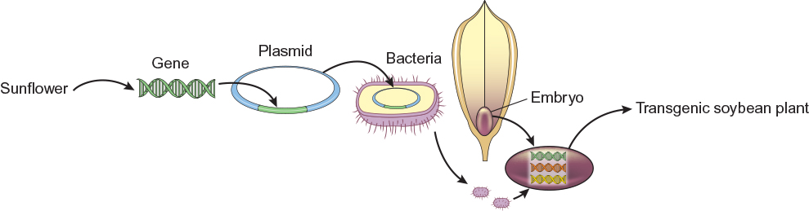

Student worksheet answers

1.13 Genetic engineering is used in medicine

Pages 34–35

Genetic engineering

1 What are the germ line cells of an organism?

The cells that eventually become gametes

2 Place the following gene-cloning steps in the correct order by labelling the diagrams as 1–5.

|  |  |
| --- | --- |
|  | 4 |
|  | 2 |
|  | 5 |
|  | 1 |
|  | 3 |

3 When a DNA fragment is incorporated into a plasmid vector, what molecule is formed?

Recombinant DNA

4 Complete the table summarising the applications of gene cloning and gene therapy using the examples of insulin production and cystic fibrosis.

|  |  |  |
| --- | --- | --- |
|  | Gene cloning | Gene therapy |
| Example | Insulin production | Cystic fibrosis |
| Description | A human insulin gene is inserted into a bacterium, which then produces the insulin protein that can be purified and given to patients. | A healthy CF gene is inserted into a harmless virus. The virus is sprayed into the nose and enters lung cells of the CF patient. These cells divide, so new cells will also have the healthy CF gene. |
| Advantages | Large quantities can be produced in bacteria that divide rapidly. Avoids rejection issues associated with using pig insulin. | Increases the lifespan of CF patients. |
| Disadvantages | Answers will vary. | Can only be used in somatic cells, therefore the healthy gene will not be passed on to offspring. |

5 Stem cells are undifferentiated cells. What does this mean?

The cells have not yet matured to become specialised cell types such as muscle, bone etc.

6 The use of ‘excess embryos’ is seen to be unethical by some people. Why?

Some people see excess embryos as potential life, and they see these embryos as being deprived of life if they are used in research.

7 Write definitions for the different types of stem cells in the following table.

|  |  |
| --- | --- |
| Type of stem cell | Definition |
| Pluripotent embryonic | Stem cells obtained from embryos that can develop into most cell types in the body |
| Multipotent adult | Stem cells obtained from body cells that can only develop into certain cell types in the body |
| Induced pluripotent | Multipotent adult stem cells that have been turned back into pluripotent cells |

Extend your understanding

8 Why would scientists want to turn multipotent adult stems cells back into pluripotent stem cells?

Multipotent adult stem cells are seen as more ethical to use in research and medical treatments than embryonic stem cells, which are unable to be used. Multipotent adult stem cells are unable to differentiate into the many different cell types that embryonic pluripotent stem cells can. Being able to turn them back into pluripotent stem cells means they could be used in research and to treat diseases such as multiple sclerosis.